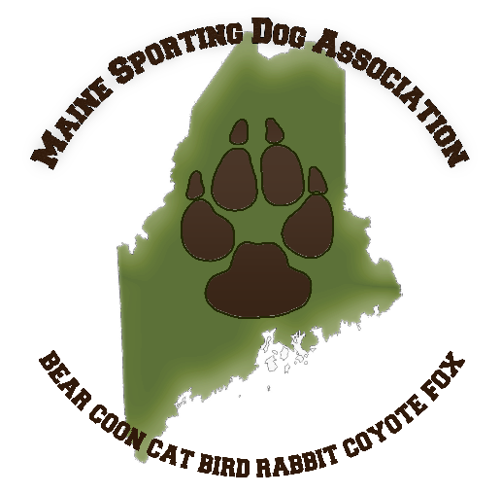
Maine Sporting Dog Association Youth Essay Contest
Prize: Maine Youth Lifetime Hunting License

Essay must be received by Saturday, April 24th at 8am via mail, email, or in person to an officer (Kara, Craig, or Brittany).

Your Name: ________________________________________________
Your Age (must be 15 years old or younger to qualify): _____________
Mailing Address: ____________________________________________
City/State/Zip: ______________________________________________
Email Address: ______________________________________________
Phone Number: _____________________________________________
Are you/your family current members of the Maine Sporting Dog Association (for 2020/2021)? ______________
Have you ever participated in a Maine Sporting Dog Association event? _________________________________
Do you currently own sporting dogs? _____________________________________________________________
If yes, what activities do you participate in with them? _______________________________________________
Please select a prompt from the options below and complete a typed, single page, size 12 font, double spaced essay on a separate page with your response.
- What is a lesson that you have learned working with dogs that you will remember for the rest of your life?
- Tell us your favorite sporting dog story. Why is it your favorite?
- How do you define a sporting dog? And why?
- Should activities with sporting dogs be considered human sports? Why or why not?
Please submit your essay by April 24th at 8am via one of the methods below:
- Email to mainesportingdog@gmail.com
- Mail to Brittany Currier | 23 Bishop Road | Plymouth, ME 04969 – Essay must be RECEIVED BY April 24th
- Deliver in person to Kara Hodgin, Brittany Currier, or Craig Wade.

